?????????????????????????????????

Abstract

Copyright is held by the author/owner(s).

CHI 2010, April 10–15, 2010, Atlanta, Georgia, USA.
ACM 978-1-60558-930-5/10/04.
Sreekar Krishna, Shantanu Bala, Troy McDaniel, Stephen McGuire and Sethuraman Panchanathan
Center for Cognitive Ubiquitous Computing (CUbiC)
School of Computing, Informatics and Decision Systems Engineering
Ira A. Fulton School of Engineering
Arizona State University
Sreekar.Krishna@asu.edu, Shantanu.Bala@asu.edu, Troy.McDaniel@asu.edu, Panch@asu.edu

In this paper, a novel interface is described for enhancing human-human interpersonal interactions. Specifically, the device is targeted as an assistive aid to deliver facial expressions of an interaction partner to people who are blind and visually impaired. Vibro-tactors, mounted on the back of a glove, provide a means for conveying haptic emoticons that represent the six basic human emotions and the neutral expression of the user’s interaction partner. Design details of the haptic interface and the haptic icons are provided, along with a preliminary user study.

Keywords
Vibrotactile glove, Basic facial expressions, Bilateral interpersonal interaction, Haptic interface

ACM Classification Keywords
H.5.2. Information interfaces and presentation (e.g., HCI): User Interfaces, Haptic I/O. H.5.3. Information interfaces and presentation (e.g., HCI): Group and Organization Interfaces, Synchronous interaction. K.4.2. Computing Milieux: Computers and Society, Assistive technologies for persons with disabilities.

General Terms
Design, Human Factors, Experimentation, Verification

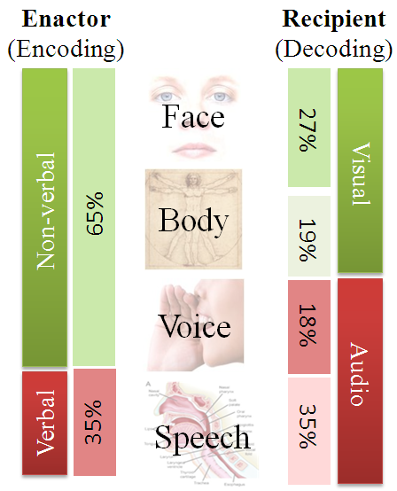
Introduction
Nearly 65% of all human interpersonal communications happen through non-verbal communication cues [1]. While speech encodes the information content in a bilateral interpersonal interaction, non-verbal cues facilitates an elegant means for delivery, interpretation and exchange of this verbal information. For example, eye gaze, iconic body or hand gestures, and prosody enable effective and seamless role play in social interpersonal interactions. People communicate so effortlessly through both verbal and non-verbal cues in their everyday social interactions that they do not realize the complex interplay of their voice, face and body in establishing a smooth communication channel. A major portion of the non-verbal communication (72% [2]) takes place through visual cues encoded on the face and body of the interaction partners. See Figure XXX. Unfortunately, people who are blind and visually impaired cannot access this huge chunk of interpersonal information independently.
Figure 1: Relative importance of a) verbal vs non-verbal cues, b) four channels of non-verbal cues, and c) visual vs. audio encoding & decoding of human interpersonal communicative cues.
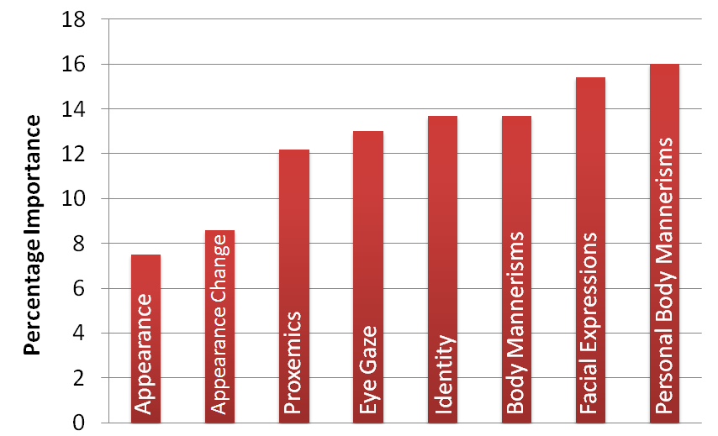
While most persons who are blind or visually impaired eventually make accommodations for this lack of information and lead a healthy personal and professional life, the path towards learning effective accommodations could be positively effected through the use of assistive aid. Specifically, children with visual disabilities invariably find it very difficult to learn social skills, while growing amongst sighted groups, leading to social isolation and psychological problems [3]. Social disconnect due to visual disability has also been observed at college level [4] where students start to learn professional skills and independent living skills. In the US alone, the unemployment rate among persons who are blind is 19% [5] and 55% [6] among people with some form of visual impairment. Assistive technologies that can enrich interpersonal social interactions could prove beneficial for persons who are blind or visually impaired.
Figure 2: Self report importance of visual non-verbal cues obtained through an online survey of target population and specialists [7].

Motivation
In order to understand the importance of visual social cues, we conducted a web based survey where the participants (16 persons who were blind, 9 with low vision and 2 sighted specialists in the area of visual impairment) rated the importance of 8 social needs that were identified from two open-ended focus groups [7]. Figure XXX shows a non-parametric rank average analysis of the participant’s responses. The participants responded on a 5 point Likert Scale, 5 implying strong agreement to 1 implying strong disagreement.
The rank ordered social needs list shows that participant’s most important need corresponds to feedback on their own body mannerism and how it was affecting their social interactions. Following this was their need to access facial expressions, body mannerisms, identity, eye gaze, proxemics (location) and appearance of their social interaction partners, in the presented order. Recently, in [8], we proposed and demonstrated a methodology to detect stereotypic body mannerism (body rocking) towards providing social rehabilitation for people who are blind and visually impaired. Focusing on the next important social need from the above table, in this paper, we propose a methodology to deliver facial expressions of the social interaction partner to a person who is blind or visually impaired.

Design Considerations
The human face is very dynamic when it comes to generating important non-verbal communicative cues. Subtle movements in the facial features can convey great amounts of information. For example, slight opening of the eyelids conveys confusion or interest, whereas a slight closing of the eye lids conveys anger or doubt. Similarly, subtle changes in head position convey significantly distinct non-verbal cues. This high dimensionality of human face and head related cues requires careful design considerations when it comes to delivering social cues to people who are blind and visually impaired.
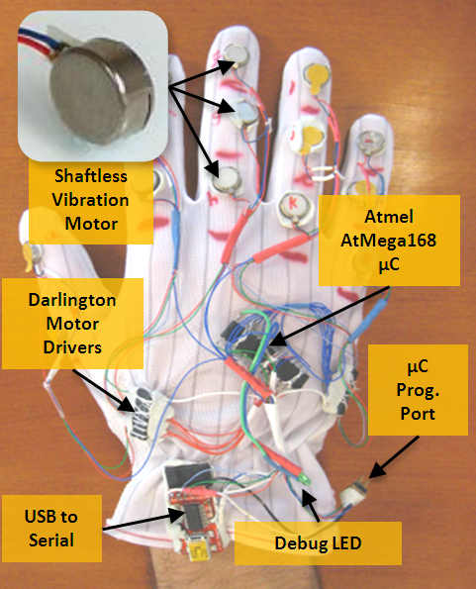
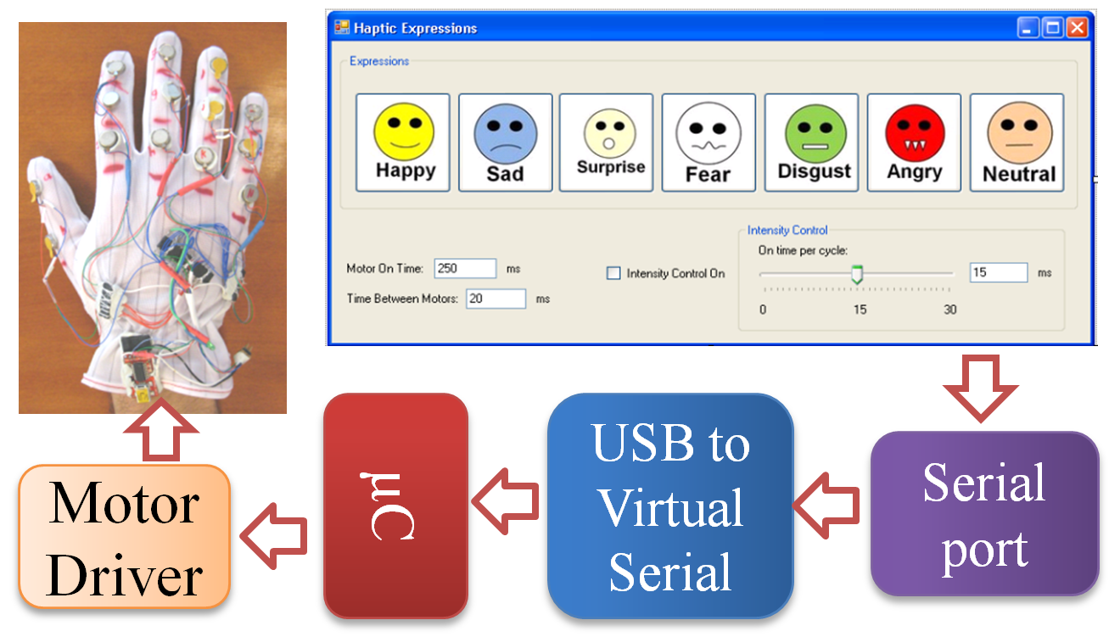
People with visual disabilities have a natural tendency accommodate for the lack of a primary sensory channel by relying on other senses, especially hearing. For example, with the aid of ambient noise in a room they can gauge approximately how big a room is. This implies that assistive devices aimed at social aid have to carefully consider how they deliver high bandwidth data streams relating to the facial and head movements of the user’s interaction partners. While audio cueing has been heavily exploited in the past for assistive aids (like color detector, currency recognizer, note taker, etc.), touch based delivery is relatively underutilized, except for Braille. Further, independent focus group studies in our lab have revealed a discomfort for audio based cueing in the target population. To this end, here we explore the use of vibrotactile cueing on the back of human palm (the human hand has a very large representation in the somatosensory cortex of the brain) to be both versatile and functionally elegant.
Figure 3: System level architecture of the vibrotactile glove. Software running on a PC controls three dimensions of the vibration patterns, including magnitude, location and duration.

Related Work
Very little research addresses the development of social assistive devices for persons with visual disabilities. Only recently social assistance has started to emerge as an important assistive technology problem [3] [4]. To the best of the author’s knowledge only one related work focuses on the issue of delivering facial information to people who are blind. [9] developed a haptic chair for presenting facial expression information. It was equipped with vibrotactile actuators on the back of the chair forming a inverted Y. A camera mounted elsewhere tracks the mouth of an interaction partner and vibrates along any one of the three axis of the Y, based on whether the interaction partner was neutral, happy, sad or surprised. No formal experiments were conducted with the target population, but for a brief pilot study with sighted students. Further, this solution had the obvious limitation that the user needed to be sitting in the chair to use the system.

The Vibrotactile Glove

Construction:
The vibrotactile glove consists of 14 tactors (vibration motors) mounted on the back of the fingers, one per phalange. The 14 motors correspond to the 14 phalanges (12 motors, 3 each on the index finger, middle finger, ring finger and the pinky, 2 on the thumb) on the human hand. Figure XXX shows the vibrotactile glove with the details of its implementation. Precision Microdrive’s pancake shaftless vibrators are used as the primary vibrotactile actuator which provides a net lateral vibration across the skin, above the phalanges of the fingers. The control software (implemented on a Windows OS based PC) interacts with the glove enabling or disabling motors according to pre programmed spatio-temporal vibration patterns. The glove has all the necessary hardware to respond to the control commands emanating for the PC and it is USB bus powered.

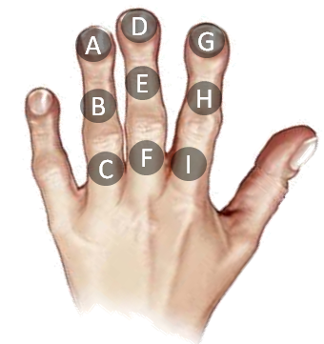
Haptic Icons of Emotions:
Figure 4: Mapping of Group 1 and Group 2 haptic expression icons to the central three fingers (9 Phalanges) of the vibrotactile glove.

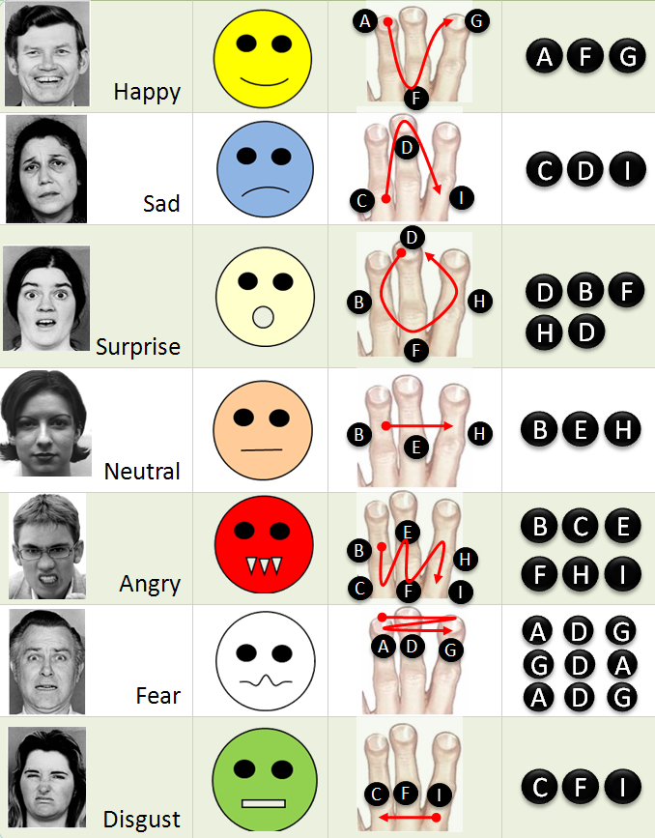
While the versatility of the vibrotactile glove allows it to be used for various applications, here we discuss the specific application in focus of delivering the six basic facial expressions along with the neutral face of an interaction partner. To this end, we have used only the three central fingers on the glove which includes the 9 vibrators (phalanges) as shown in the Figure XXX. Humans rely heavily on the shape of the mouth and eye area to determine the expression of the interaction partners. Here we focused on the mouth area to derive motivations for the spatio-temporal haptic icons. In order to represent the seven expressions in their haptic equivalent, we designed haptic icons that were motivated by two important factors, 1) Icons similar to the visual emoticon that are already in popular use, like Happy, Sad, Surprise and Neutral where the mouth shapes prominently represent the expression, and 2) Icons like Anger, Fear and Disgust where the mouth area alone does not convey the expression thereby forcing us to create haptic icons that could evoke a sense of the expression in question, referred here as the Auxiliary Icons. Figure XXX, provides details of the vibrotactile icons.

Group 1 – The visual emoticon motivated haptic icons:
The Group 1 haptic icons primarily represent popular emoticons that are in wide use within the Instant Messaging community. These icons mostly model the shape of the mouth. 1) Happy is represented by a U shaped pattern, 2) Sad by an inverted U, 3) Surprise by a circle, and 4) Neutral by a straight line.

Group 2 – The auxiliary haptic icons:
Anger, Fear and Disgust cannot be conveyed through the mouth appearance alone. To this end, we resorted to defining haptic patterns that were unique from what was already defined for Group 1, while keeping in mind a need to represent the underlying expression in question. 1) Anger is represented by successive vibrations on six lower phalanges representing open mouth showing the teeth during anger expression, 2) Fear is represented by very fast vibrations to the top phalanges (tips of the central fingers) in three quick successive vibration sequences representing a fast emotional response that people show towards fear, and 3) Disgust represents slightly open mouth through vibration pattern going from right to left on the bottom phalanges of the central fingers.
All patterns belonging to both Group 1 and Group 2 were designed to be 750ms long with each motor vibrating for at least 50ms. These numbers were arrived at based on pilot studies where we found that participants could not isolate vibrations and their locations if the vibration duration was less than 50 ms long. Further, patterns longer than 800 ms were considered to be too long by the participants, while patterns shorter than 600 ms were too confusing for them and training time accuracies were unacceptable.

Experiment
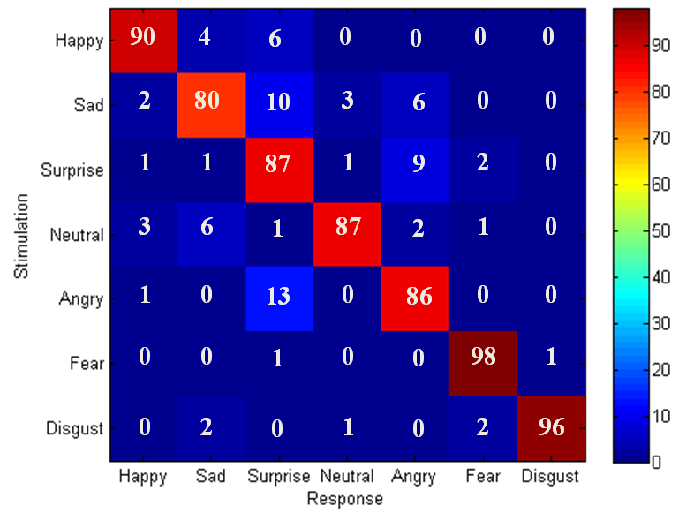
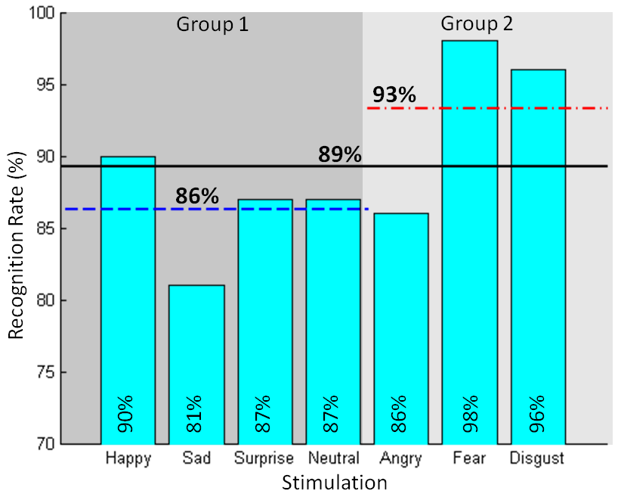
The primary goal of the experiment was to determine how well participants were able to recognize the haptic patterns. Along with the accuracy of recognizing the spatio-temporal vibrotactile cues, we were also interested in how quickly were the participants able to recognize the expression. The duration of recognition is very important in developing any assistive device for social interpersonal communication, as the human face is very dynamic and expressions change drastically over time. Psychology experiments have shown expressions to vary anywhere from 1 to 5 seconds ([1], Page 322). It is important that any device developed towards enriching social experience should react in real-social-time towards facilitating smooth interpersonal interaction.
Figure 5: Recognition rate on all 12 participants. Individual expression, Group 1, Group 2, and the overall recognition rate are presented in the graph.

Figure 6: Confusion Matrix over all the 12 participants. The rows are the stimulation and the columns are the response of the participants. Each row adds to 100 % (rounding error of 1%).

Participants:
The experiment was conducted with one individual who was blind and 11 other participants who were sighted but blind folded. It is important to note that the individual who was blind had lost his sight after 25 years of having vision. To a large extent this individual could correlate Group 1 haptic icons to his visual experiences from the past.

Procedure:
The experimenter helped each subject put on the glove and asked the subjects to keep their hand on their lap in the most comfortable position possible. The subjects were seated in a chair with a blind fold all through the experiment. Subjects were first familiarized with vibration patterns through a training phase. All 7 vibration patterns corresponding to Group 1 and Group 2 haptic icons were presented in order, during which the expression corresponding to the pattern was spoken aloud by the experimenter. The familiarization was continued until the subject was comfortable (a self report in their comfort level) in remembering all the seven expressions and their corresponding patterns.
Subjects then began the training phase in which all seven patterns were presented in random order in multiple sets, and the subject was required to identify the expression. The experimenter confirmed correct guesses, and corrected incorrect guesses. Subjects had to score 100% recognition in one set of seven expressions before they could move on to the testing phase. At the end of 15 mins of training, all subjects were moved to testing phase irrespective of their recognition accuracy. The testing phase was similar to the training phase except the experimenter did not provide feedback to subjects, and each complete expression pattern was randomly presented 10 times making a total of 7expressions x 10 times = 70 trials.

Results and Discussions

Recognition Accuracies:
Figure 5 shows the average recognition rate on all 12 participants for the seven haptic patterns. The overall recognition rate was 89%, while the Group 1 and Group 2 recognition rates were at 86% and 93%, respectively. Our hypothesis was that the haptic icons from Group 1 would be easier for the participants to recognize as they represent popular emoticons that are in wide use, but contrary to this design decision Group 2 performance was significantly higher. The Sad expression haptic icon (inverted U shape) performed the worst within Group 1 with a recognition rate of only 81%. Studies are underway to determine the nature of the haptic cues in Group 2 that make them significantly better than Group 1, especially the Fear and Disgust expressions where the recognition rates were 98% and 96%, respectively.
Figure 6 shows the confusion matrix of all the seven expressions. The rows represent the stimulation while the columns represent the average response from the subjects. As can be seen, the diagonals correspond to the bar graph shown in Figure 5. The off-diagonal elements represent the confusion between expressions. These off-diagonal elements provide insights into the parameters that control effective and responsive haptic patterns. While subjects confused Sad and Neutral expressions with various others (mostly Group 1), Anger and Surprise show exchangeability, where there is strong confusion between these expressions. Fear and Disgust are strongly isolated from the rest of the other expressions as they were very well recognized by the subjects.
While the results presented in Figure 5 and Figure 6 correspond to the average of all the 12 participants, the person who is blind performed the learning task very well with an overall recognition accuracy of

Conclusion and Future Work

References
[1] M.L. Knapp and Nonverbal Communication in Human Interaction, Harcourt College Pub, 1996.
[2] N. Ambady and R. Rosenthal, “Thin Slices of Expressive behavior as Predictors of Interpersonal Consequences : a Meta-Analysis,” Psychological Bulletin, vol. 111, 1992, pp. 274, 256.
[3] D. Jindal-Snape, “Generalization and Maintenance of Social Skills of Children with Visual Impairments: Self-Evaluation and the Role of Feedback,” Journal of Visual Impairment and Blindness, vol. 98, 2004, pp. 470-483.
[4] K. Shinohara and J. Tenenberg, “A blind person's interactions with technology,” Commun. ACM, vol. 52, 2009, pp. 58-66.
[5] D.M. Zuckerman, Blind Adults in America: Their Lives and Challenges, Washington DC: National Center for Policy Research for Women & Families, 2004.
[6] E. Steinmetz, Americans with Disabilities: 2002 Household Economic Studies, Current Population Reports, Dept. of Commerce, US Census Bureau: 2002.
[7] S. Krishna, D. Colbry, J. Black, V. Balasubramanian, and S. Panchanathan, “A Systematic Requirements Analysis and Development of an Assistive Device to Enhance the Social Interaction of People Who are Blind or Visually Impaired,” Workshop on Computer Vision Applications for the Visually Impaired (CVAVI 08), European Conference on Computer Vision ECCV 2008, Marseille, France: 2008.
[8] S. Krishna, N.C. Krishnan, and S. Panchanathan, “Detecting Stereotype Body Rocking Behavior through Embodied Motion Sensors,” Annual Conference of the Rehabilitation Engineering and Assistive Technology Society of North America, New Orleans, LA: 2009.
[9] S. Rehman, L. Liu, and H. Li, “Vibrotactile Rendering of Human Emotions on the Manifold of Facial Expressions,” Journal of Multimedia, vol. 3, 2008, pp. 18-25.
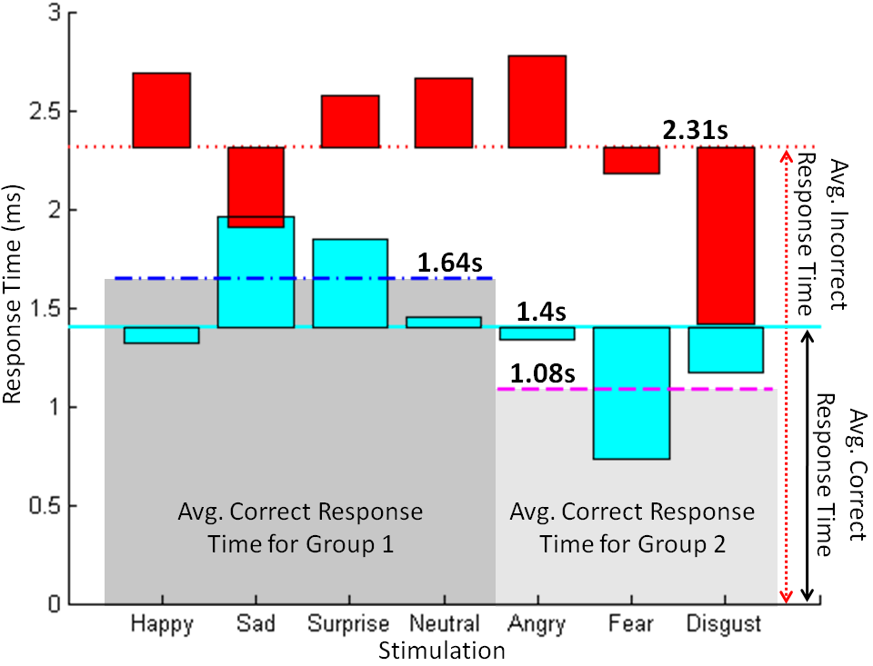
Figure 7: Average response time for all 12 participants. Four important results are shown above, 1) Avg. response time with correct answer, 2) Avg. response time for wrong answers, 3) Avg. response time for Group 1 icons, and 4) Avg. response time for Group 2 icons. 3 and 4 are averaged only on the correct responses.

